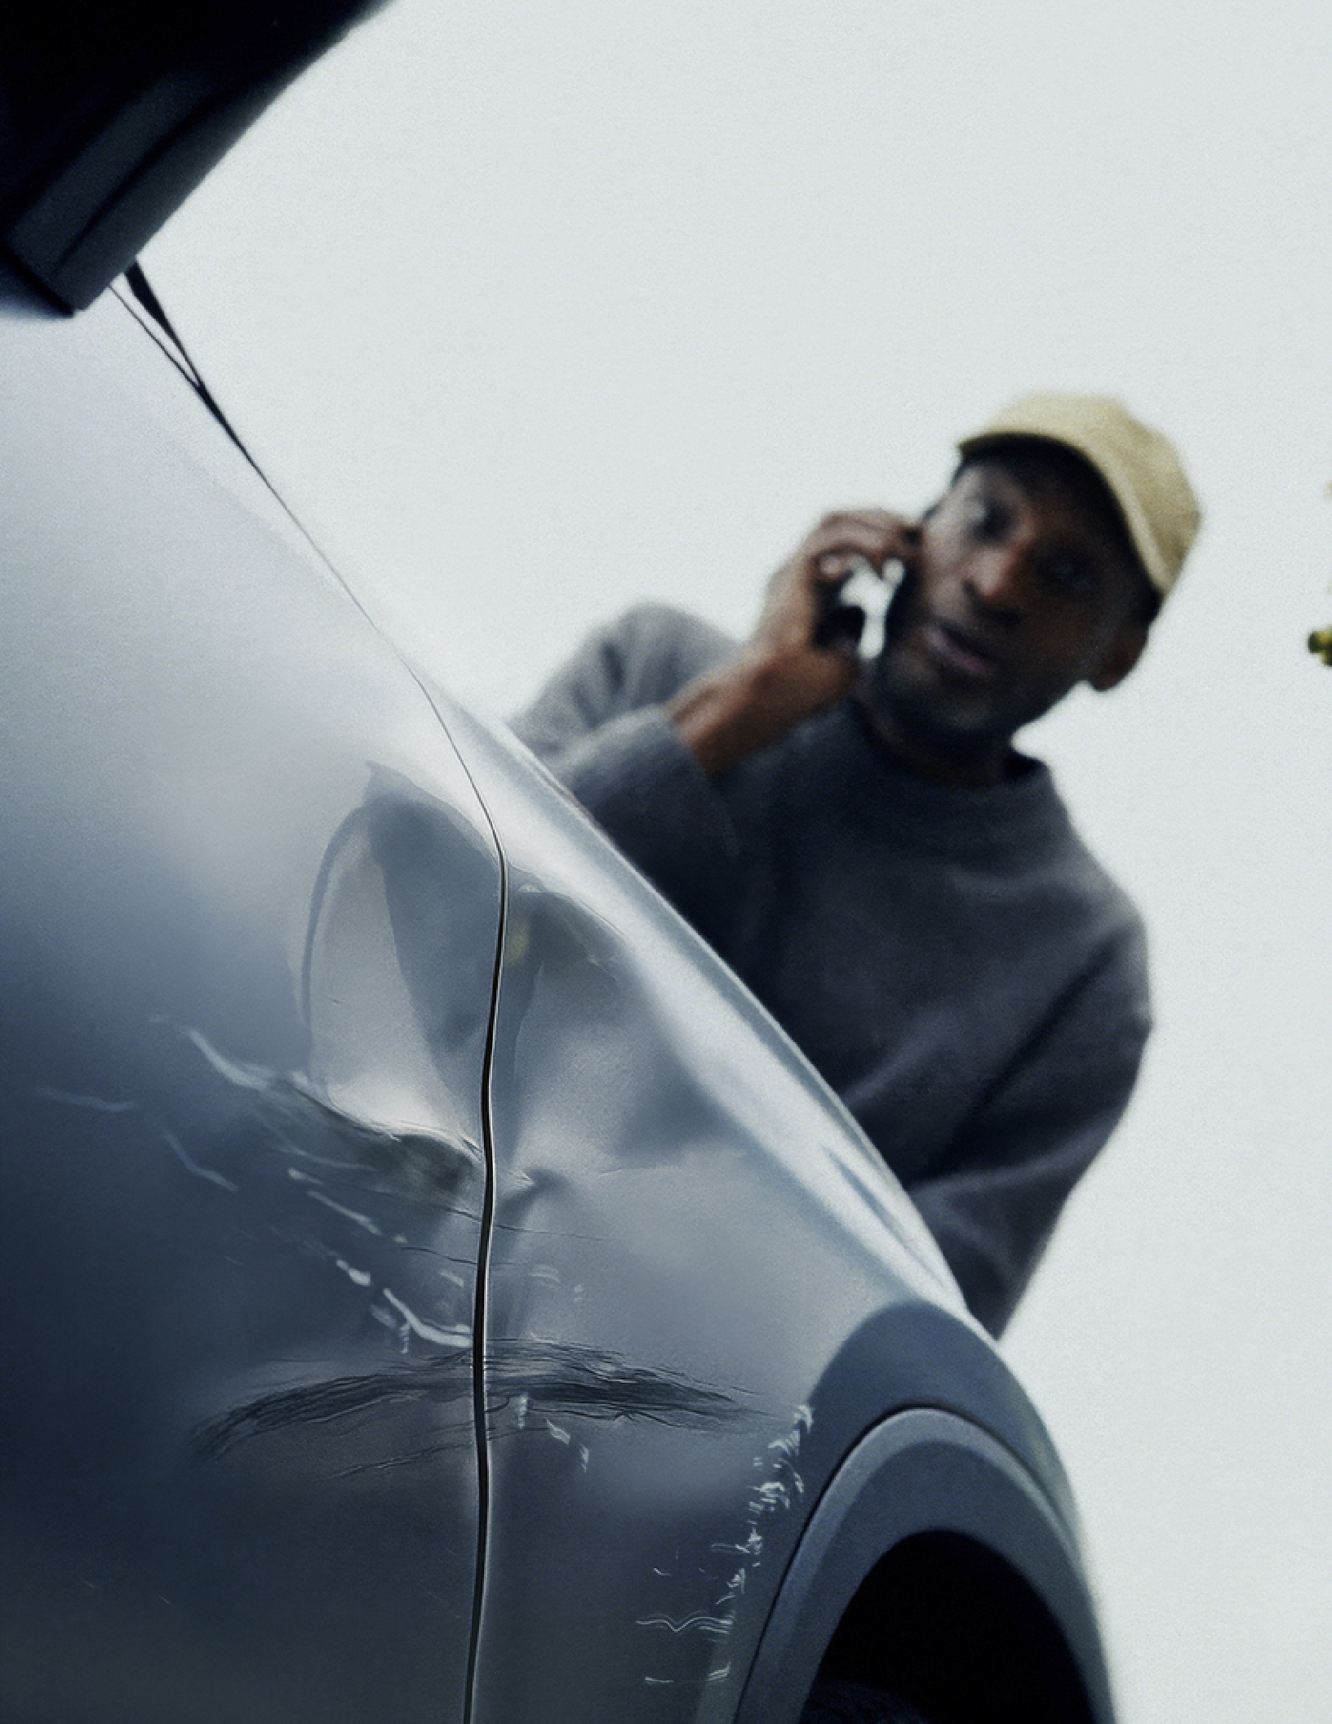





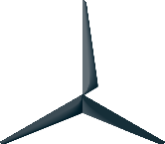




Tools & Equipment List



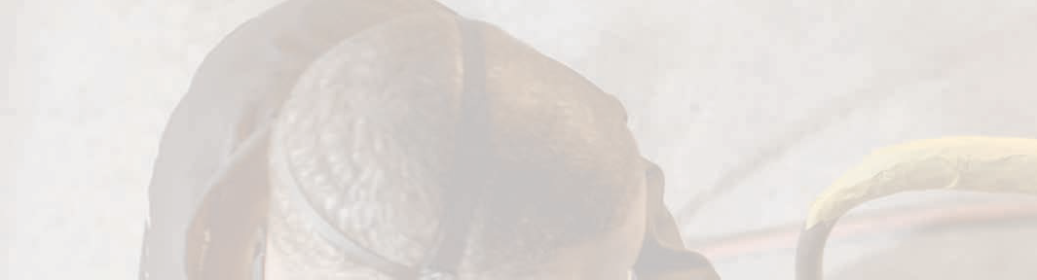



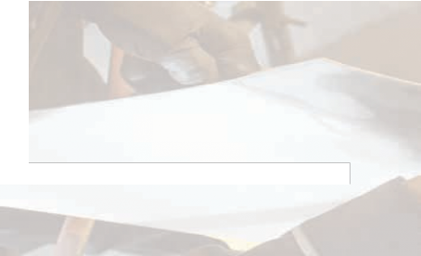
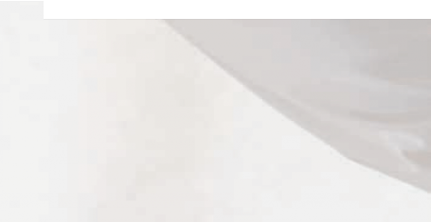





















Overview of Programs
2

Mercedes-Benz Certified Collision Program Tiers

BASE
These facilities can perform collision repair work on all Mercedes-Benz Passenger cars except those requiring aluminum welding.

Authorized to perform all collision repairs on all Mercedes-Benz passenger vehicles including aluminum structural repairs.


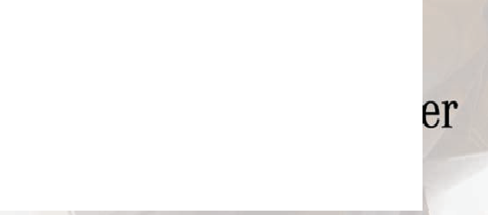
Authorized to perform collision repairs on all Mercedes-Benz Electric Vehicles.
Note: Must be Elite certified

Authorized to perform structural and cosmetic repairs on Sprinter and Metris Vehicles.

Mercedes-Benz Certified Collision Program Tool and Equipment Standards
Straighten Bench & Measuring Systems
15
Benches 5
Hydraulic Pulling Tower 5
Side Gantry/Side Portal 6
Straightening Jig Sets/Kits 6
Measuring Systems 6
Vehicle Lifts ₇
Aluminum Repair ₈
Dedicated Aluminum Tool Kit and Panel Repair 9
Safety Vacuum 9
Riveting & Welding
Riveter 10
Inverter Spot Welders 10
MIG Welder 11
Glass Replacement 11
Vehicle Refinishing
Paint Systems 12
Paint Mix Room 12
Spray Booth 12
Paint Gun 13
Paint Thickness Gage 13
Wire Harness Repair 14
Recommended
Xentry Unit 15
Headlamp Aiming Unit 15
Refrigerant Equipment Adhesive Tools 16
Cutting Tools 16

Mercedes-Benz Elite Certified Collision Program
Aluminum Welder 17
Mercedes-EQ Collision Certification
Heavy Duty Two Post Lift 18
Mercedes-Benz Battery Table 18
Xentry 18
Charging Station 18
Mercedes-Benz Vans Collision Certification
Straightening Bench 19
Straightening Bench Fixtures 19
Spray Booth 19
Heavy Duty Two Post Lift 20

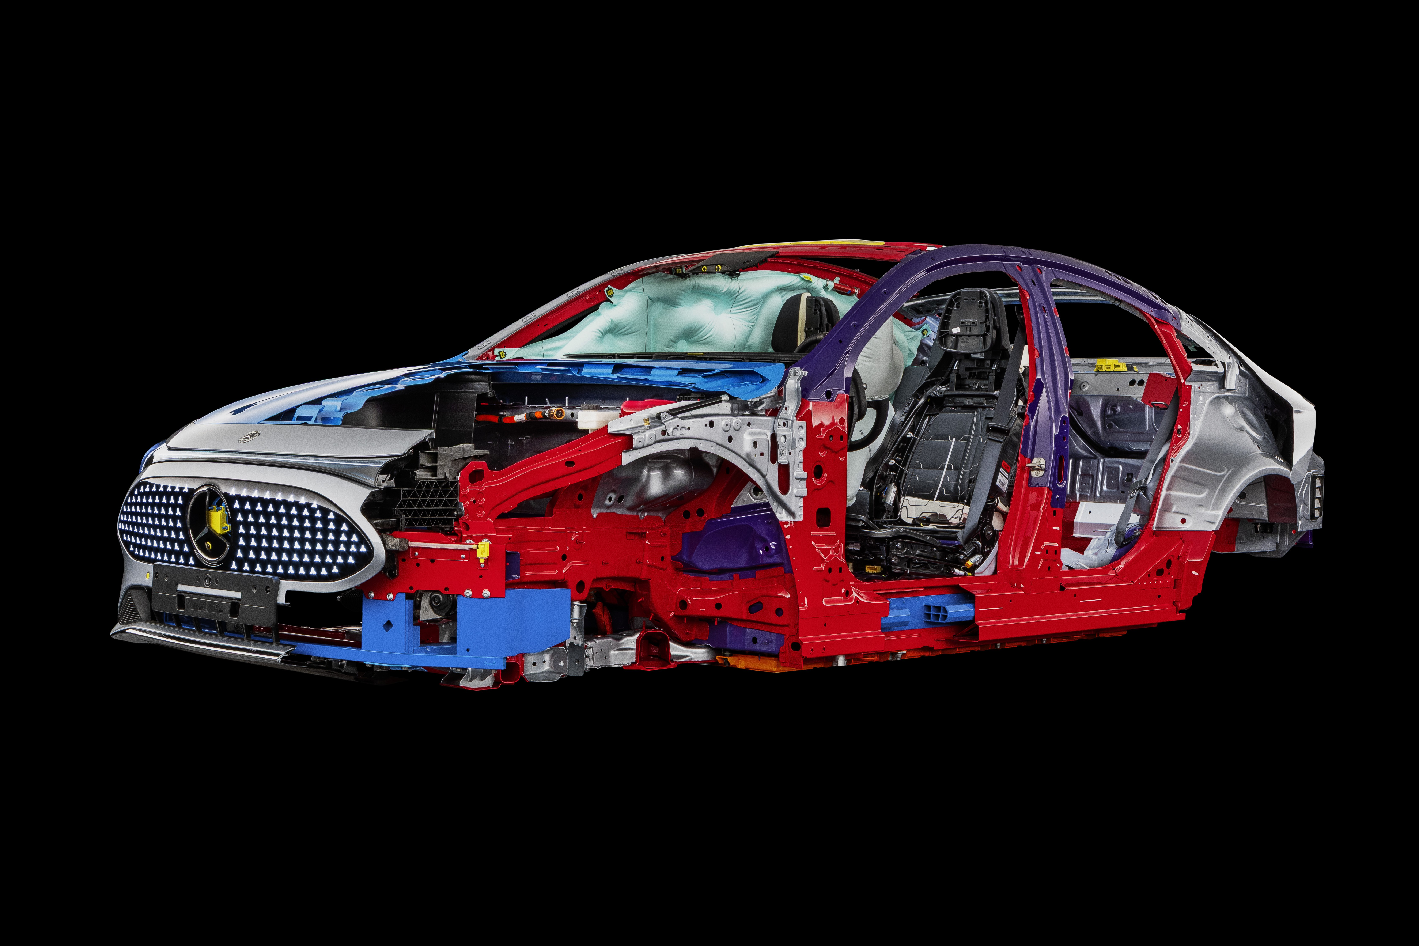

Mercedes-Benz Certified Collision Program Tool and Equipment Standards

Collision centers must meet MBUSA Certified Collision Program Standards in order to obtain or renew certification. Possessing the necessary Tools and Equipment is required to meet standards. Failure to meet any of the required standards will result in a Corrective Action Plan (CAP) that will be agreed upon by the collision center, sponsoring dealer, MBUSA Field Management and the MBUSA Collision Team. In addition to the following tool and equipment standards, an inventory of basic industry tools is expected to be onsite. Please refer to www.mbcollisioncenters.com for latest updates

Straightening Bench Vehicle Mounting Kits

Benches
Facilities are required to have an approved XL version of benches. Facility must have at least 2 technicians on staff that have completed training on their chosen straightening bench system to maintain certification. The standard size benches will not support the current S-class or Maybach Chassis.

Mercedes-Benz approved straightening equipment:
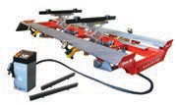
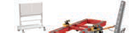
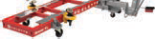
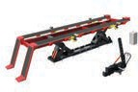
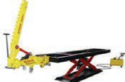
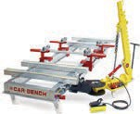

Celette Griffon XL Set (BX:GXL08.5812)
Celette Sevenne XL Set (SVN09XL.3112)
Celette Rhone XL (RH18XLM4221.6)
Carbench Manta XL (160AA154/5150/F/R)
Carbench Muraena/Piranha XL (AA265/5150/F/R)

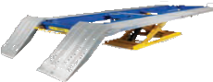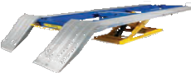

Car-O-Liner BR5500 Frame & Tilt Lift

(CARNA34640KT B83)
Car-O-Liner BR6300 Frame & Tilt Lift (CAR33907-KIT)
Additional Option: Required for Vans certification.

Hydraulic Pulling Tower
Facilities are required to have a hydraulic puller for straightening. Puller must be compatible with the approved straightening systems.

Mercedes-Benz approved hydraulic pull posts:
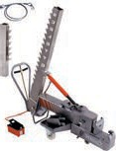
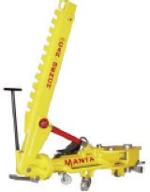
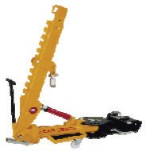
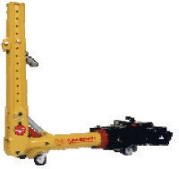
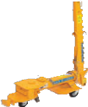

Celette Pulling Unit Sevenne (must fit Sevenne XL and Griffon XL SVN19.301)
Carbench Manta Pull Post (article number PT36)
Carbench Piranha Pull Post (article number PT32)
Carbench Muraena Pull Post (article number PT30/1)
Car-O-Liner Draw Aligner (article number CAR30346 D16)
5

Side Gantry/Side Portal
Facilities are required to have a side gantry to measure lateral points. Gantry/portal must be compatible with the approved straightening systems. Mercedes-Benz approved gantry/portals: Note: Car-O-Liner does not have a side gantry- repairs completed by measurement and test fitting.
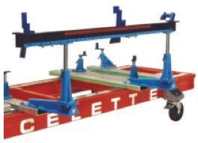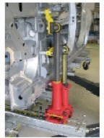

Celette Gantry
(article number 9113.063)
Carbench Kit for Lateral Points (article number C281)

Straightening Jig Sets/Kits
Facilities are required to use jig set/kits to straighten a Mercedes-Benz unibody or frame.
If the facility has the approved Carbench System, then they must have the Mercedes-Benz Universal Jig Set.
If the facility has the approved Celette Systems, then the facility must own the towers as well as the cross members. If the facility has the approved Car-O-Liner System then the facility must have the full EVO 3-3 MB Kit.
The vehicle specific jigs may be rented.
Mercedes-Benz recommends that the facility own the jigs for the more common models (C-Class, E-Class, GLE...).

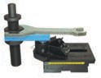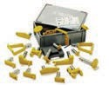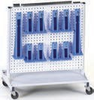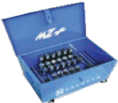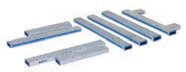

Celette Mercedes Anchoring Set (9212.013)
Celette Jig
(vehicle model specific)
Celette MZ
(article number MZ450.925)
Celette MZ+
(article number MZ2500.MB01)
Celette Cross Member Set for Mercedes-Benz (article number 955A.9412)

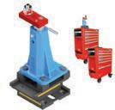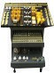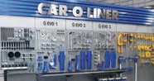

Cameleon Premium Universal Jig System from Celette
(Ref # CAM02.162)
Carbench (universal Jig Set)
Car-O-Liner EVO 3 MB System

Measuring Systems
Mercedes-Benz recommends that facilities own a measuring system to provide documentation if required by an insurance carrier prior to setting up on a fixture bench for repair.

Mercedes-Benz recommended manufacturers:

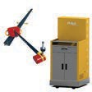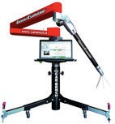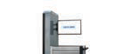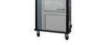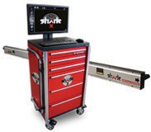

Celette 3D NAJA Carbench Contact Evolution
Car-O-Liner Car-O-Tronic Vision 2 X3 Mercedes-Benz.
Required when using Car-O-Liner straightening bench.
Blackhawk Shark
6

Vehicle Lifts

Facilities are required to have a two post lift or "In Ground" lift.
Must be UL & CE approved in conjunction with OSHA, as well as state and local codes and regulations.

Mercedes-Benz recommended manufacturers:
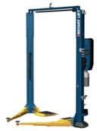
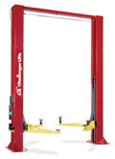
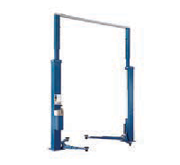
Rotary Challenger Nussbaum & Company

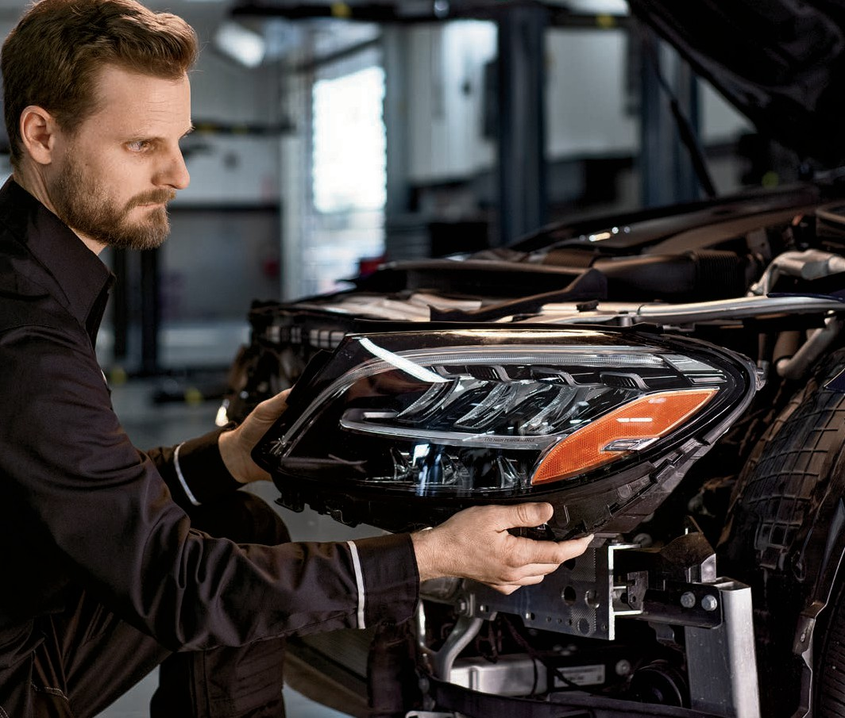

Aluminum Repair

Facilities are required to have a dedicated aluminum work place.
Dedicated aluminum area or room (large enough for at least one vehicle) completely partitioned off from areas that contain steel dust to avoid contamination/ corrosion. Area may be a hard walled room or have curtains with separate lighting that contains a grinding dust extractor/ vacuum. Curtains must provide a separation from other areas. Steel swarf and grinding dust can cause corrosion to aluminum. Aluminum dust can be explosive; therefore proper housekeeping of the area must be maintained.
Must be UL & CE approved in conjunction with OSHA, NFPA, EPA as well as state and local codes and regulations.

The minimum requirements are:
- Walls/curtains should be made from a fire resistant material.
- Curtains must be no more than 2” off the floor.
- Curtains must be 12’ in height or 3’ from the ceiling
- Washable walls and floors for wet cleaning are necessary in order
to control aluminum dust buildup. (cleaning with compressed air can cause an explosion)
- The workplace should contain few horizontal surfaces, pipes and lines so that less dust is deposited and to allow cleaning by vacuuming or sweeping.
- Regular cleaning of the workplace must be carried out and documented.
- A110V/230V power supply should be present.
- A compressed-air connection with min. 6-8 bar pressure is required. (connection for pneumatic tools)
- Existing straightening benches and straightening bracket sets can be used alternately provided they are cleaned thoroughly beforehand.
- The vehicle being repaired must be covered, with the exception of the immediate repair area, in order to avoid galvanic corrosion other areas of the vehicle.
If grinding work on steel parts is necessary, e.g. on steel rivets, the aluminum parts must be protected against flying sparks, and steel dust to prevent corrosion on the aluminum.
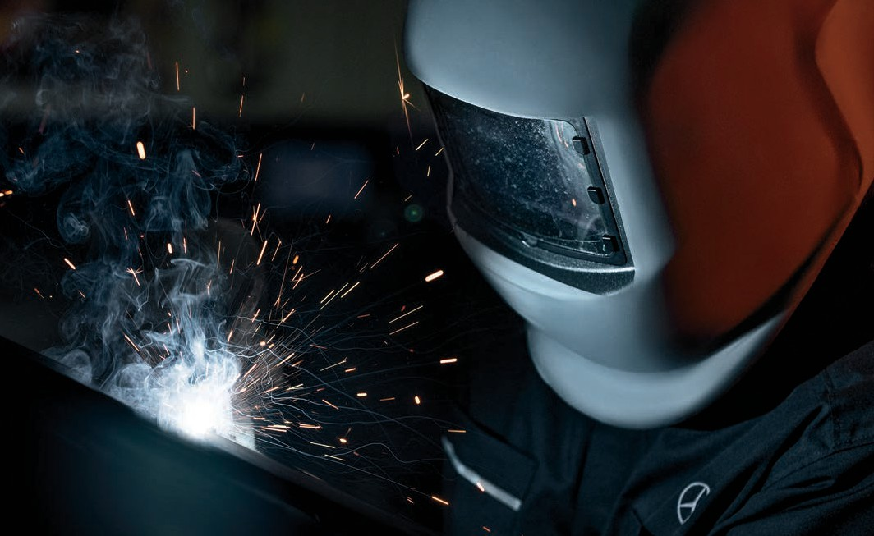

Dedicated Aluminum Tool Kit and Panel Repair

Facilities must have a separate tool cart/trolley that are dedicated to aluminum cosmetic repairs.
Tool trolley must be clearly labeled as the storage for the aluminum tools. Items in trolley can be purchased individually if preferred. Please check with your local suppliers for Mercedes-Benz approved packages and available kits.

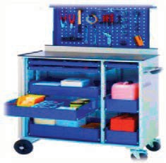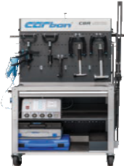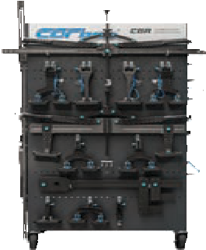

Wieländer & Schill
Aluminum Tool Kit with dedicated hand tools and AK 98 Panel Repair kit

Safety Vacuum

Carbon
Mercedes-Benz Carbon Aluminum Panel Repair Kit Complete Workplace

Facilities are required to have an explosion proof immersion/wet-type aluminum dust vacuum that meets "NFPA code 660, Standards for Combustible Dusts and Particulate Solids". Vacuum should be located and used in the aluminum workplace.
Must be UL & CE approved as well as meet all state and local codes and regulations. Mercedes-Benz recommended units:
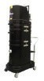
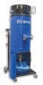

Ruwac Immersion Aluminum Dust Unit
(article number NA35-110)
Eurovac Portable Wet Mix Dust Collector (article number SYS-050-18300000)

Riveting & Welding

Riveter

Facilities are required to have a Mercedes-Benz approved Riveter. Mercedes-Benz approved tool:
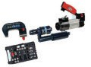
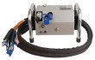

Wieländer & Schill Xpress 800 Push Pull (article number 70002 & 70004)
TKR Automotive GmbH PNP 90 SNW XT2 (article number WZS-TKR-00000180)
*Please note, this is the Heavy Duty Version. The PNP 90 UN
2.0 (WZS-TKR-00000050) is not approved. Facilities have the option to upgrade their PNP 90 UN 2.0 to the HD SNW XT2 with a Daimler approved kit (article number 500006)

Inverter Spot Welders

Facilities are required to own an approved spot welder or one that meets the specifications as called out in WIS- Document # OF60.00-P-0002-01K. Mercedes-Benz approved units:
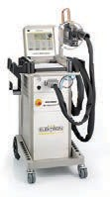
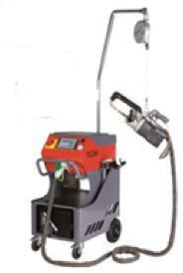
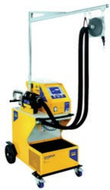
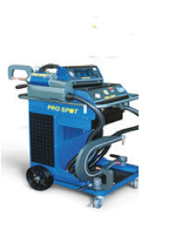
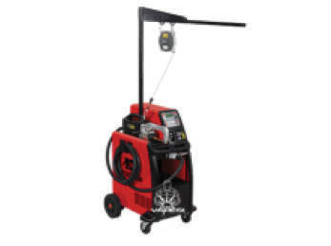

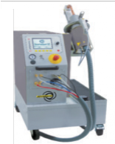

Elektron: Multispot MI-100 Control_MTC6000
(article number 520 476)
Cebotech-Tecna Spot 14000 (article number 3664P7)
GYSPOT Inverter PTI s7 (article number D20801)
Pro Spot i5 Smart Welder (article number i5)
Telwin S.P.A Inverspotter 14000 Smart
(article number 823077)
Wieländer & Schill InvertaSpot GT Automatic (article number 932436)

MIG Welder

Facilities are required to own a MIG welder.
If the facility is pursuing or has an Elite Certification, then Collision Center is required to own one of the approved models below or a unit that meets, (or exceeds), the specifications listed in WIS for MIG Welders- Document # OF00.00-P-0004-01K.

Collision Centers are required to have SG-CuSi3 wire for brazing. Mercedes-Benz recommended units:
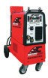
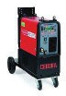
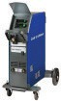
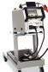

CeboTech MultiMig 621 Inverter (Chief)
(article number EL900021)
CeboTech Cebora-Sound MIG Pulse 2740/T Star Pulse (article number 307)
Car-O-Liner CMI3000II MB
(article number 79541368)
Elektron (BlitzRotary) Multimig 400 pulse
(article number 515908)

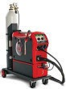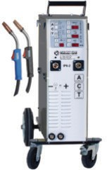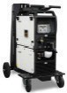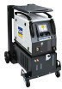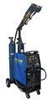

Fronius TransPuls 270i C Pulse (article number 4075095 MB)
Wieländer & Schill inverter puls IP 6-2 ACT
(article number 90413-3433-MB)
EWM AG Phoenix 355 Progress Pulse MM TKM (article number 090-005403-
59502)
GYS Neopulse 300
(article number 032767)
Prospot Smart MIG SP-5.3 (article number 900 150 28)

Glass Replacement

Facilities are required to use a cord/wire cutting Glass Removal Device.
If the facility sublets glass repairs, it must show invoices that a wire/cord device was used.

Mercedes-Benz recommended tools:
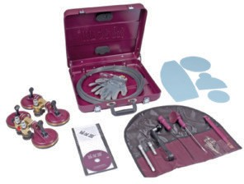
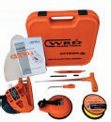

Wieländer & Schill Roll Out (article number 842010)
11
WRD Glass Removal System (Spider 3 and PRO 6 Models)

Vehicle Refinishing

Paint Systems

Facilities are required to use the approved refinishing systems. Mercedes-Benz approved refinishing systems:
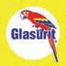
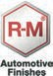

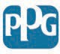
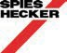
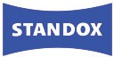
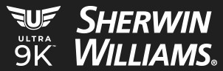

Paint Mix Room

Facilities are required to have a paint mixing room.
A mixing room provides a controlled environment to remove toxic fumes when mixing paint and prevents contamination.

Must be UL & CE approved in conjunction with OSHA, NFPA, EPA as well as state and local codes and regulations.
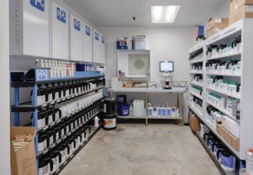
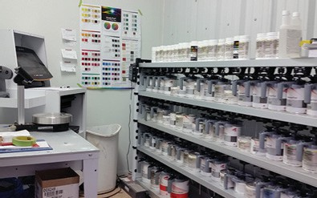

Spray Booth

Mercedes-Benz requires the facility to have a Down Draft or a Low Bake spray booth. These booths use the same chamber for painting and convection drying and utilize a make-up unit to supply the spray booth with filtered air. Must be UL & CE approved in conjunction with OSHA, NFPA, EPA as well as state and local codes and regulations.
The minimum specifications are:
- Intake and Exhaust airflow rating of 14,000 CFM
- Air filters (paint arrestors) must have a 98% efficiency.
- Lighting system which uses daylight lamp that will provide at least a 96 CRI.
- Brightness level should be at a minimum of 100 foot-candles at the cabin floor or filter grate.
- Heating unit with direct fired burners at a minimum of 1.0 MBTU
- Grade “D” quality air breathing system.

Mercedes-Benz recommended spray booths:
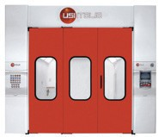
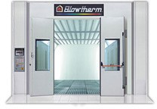
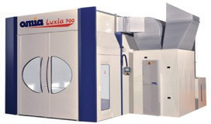
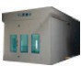
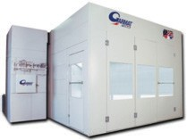
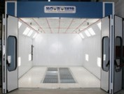
USI Italia OMIA Blow Therm Times Vision Garmat Nova Verta

Paint Gun
De Felsko PosiTector 200
Facilities are required to have an HVLP paint gun.
Must be UL & CE approved in conjunction with OSHA, EPA as well as state and local codes and regulations.
Locally sourced
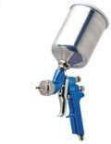
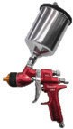
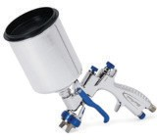

Paint Thickness Gauge
A paint thickness gauge capable of measuring paint thickness on bumper covers is required.

Mercedes-Benz recommended model:
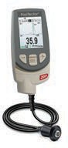

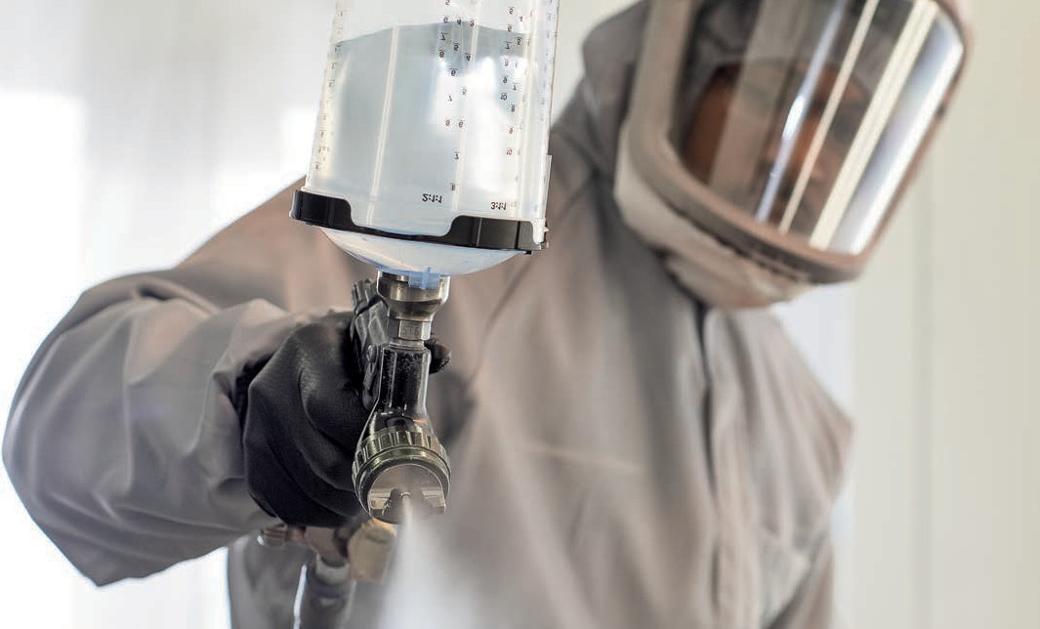

Wire Harness Repair

These items are for the repair of the vehicle’s wire harness and/or electrical connectors. Follow Workshop Information Systems (WIS) instructions for all repairs.

Facilities are required to have a Wiring Harness Repair Kit, Basic.
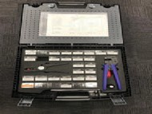

W000589139900
(Article number AR00.19-P-0100A)

Facilities are required to have the following wire rolls: Facilities are recommended to have the following wire rolls:

A 169 543 02 31:
Yellow; Roll with 100M; 0,50 MM2

A 169 543 03 31:
Yellow; Roll with 100M; 0,75 MM2

A 169 543 04 31:
Yellow; Roll with 100M; 1,00 MM2

A 169 543 05 31:
Yellow; Roll with 100M; 1,50 MM2

A 169 543 06 31:
Yellow; Roll with 50M; 2,50 MM2

A 169 543 07 31:
Yellow; Roll with 25M; 4,00 MM2

Facilities are recommended to have a Flat Wire Repair Kit.
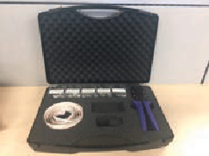
W211 589 01 99 00

Facilities are recommended to have a Welding Bead Catcher (small mat to place under wire while welding to catch welding slag).
W000589139900

Xentry Unit

Facilities are recommended to have a Xentry unit or equivalent MB software package.
Process for ordering the Hardware and Software: www.startekinfo.com > Purchase Hardware/Software > pick new user, and the options will be made available.
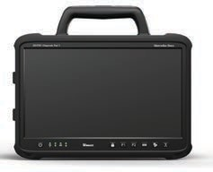

Headlamp Aiming Unit
Mercedes-Benz requires that all headlamps are aimed with a Mercedes-Benz approved device.
If facilities do not have an approved device, then work must be done at a Mercedes-Benz dealership.
Mercedes-Benz approved manufacturers:
Items in this section are required if the facility is performing the work themselves. The Facility can sublet this work to their sponsoring dealership.
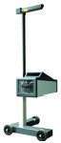
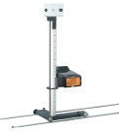

MAHA MLT 1000 MB
(Article number 649-VP 185069)
Beissbarth MLD 110
(Article number 1692104339)

Refrigerant Equipment

Mercedes-Benz requires equipment to reclaim, evacuate and/or charge systems in case work cannot be sublet to a sponsoring dealer.
If choosing to sublet, collision center must maintain invoice and have available for audit purposes. If owned, it will need to be available and functioning properly and meet OSHA, NFPA, EPA as well as state and local codes and regulations.

Mercedes-Benz recommended units:
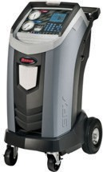

Robinair for R-134 Refrigerant RRR for Hybrid and Non-Hybrid Vehicles (article number 34788NI-H)

Items in this section are required if the facility is performing the work themselves. The Facility can sublet this work to their sponsoring dealership.

Adhesive Tools
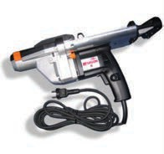
DOW 860687664 distributed by RAE

Cutting Tools
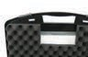
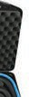
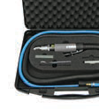
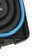
Wielander + Schill MEC600 cutting tool

Cleaning/Disinfecting
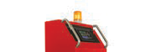

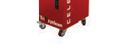
Trioxyclean Air Purifier from Celette (Ref # CEL.8003.02)

Elite Certified Collision Program

Certified Collision Centers must meet all MBUSA Certified Collision Standards in addition to the Elite Standards. The standards of the Elite Certified Collision Program include possessing the required Tools and Equipment listed below. Failure to pass any of the required standards will result in a Corrective Action Plan (CAP) that will be agreed upon by the collision center, sponsoring dealer, MBUSA Field Management and by the MBUSA Collision Team.

Aluminum Welder

Mercedes-Benz requires facilities to own an approved aluminum welder to attain Elite Certification. They can be any of the units shown below or one that meets the specifications called out in WIS under Document# OF00.00-P-0004-01K
As reviewed in the CertificationTraining,AluminiumStructuralrepairsmustuseAlSi5(4043)wirewitha1.2mmdiameter.Collision Centers must have this specific wire.

Mercedes-Benz approved units:

CeboTech MultiMig 621 Inverter (Chief)
(article number EL900021)
CeboTech Cebora-Sound MIG Pulse 2740/T Star Pulse (article number 307)
Car-O-Liner CMI3000II MB
(article number 79541368)
Elektron (BlitzRotary) Multimig 400 pulse
(article number 515908)

Fronius TransPuls 270i C Pulse (article number 4075095 MB)
Wieländer & Schill inverter puls IP 6-2 ACT
(article number 90413-3433-MB)
EWM AG Phoenix 355 Progress Pulse MM TKM (article number 090-005403-
59502)
GYS Neopulse 300
(article number 032767)
Prospot Smart MIG SP-5.3 (article number 900 150 28)

MB Electric Collision Certification

MBEVCC facilities must be Elite certified and meet these additional requirements to participate.
The standards for the MBEVCC include complying with the required Tools and Equipment standards listed below.

Mercedes-Benz Battery Table

Facilities are required to have a Mercedes-Benz Battery table.
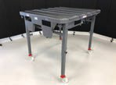
Part Number W001588005400- Order through dealer parts department

Xentry Unit
Xentry diagnostic unit or equivalent Mercedes-Benz software package with 3rd party computer is required. Process for ordering the Hardware and Software: www.startekinfo.com > Purchase Hardware/Software > pick new user, and the options will be made available.
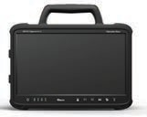

Charging Station

Facilities are required to have at least one Level 2 charging station.
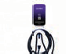
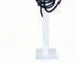
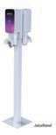

Mercedes-Benz Vans Collision Certification

MBVCCC facilities can be an add on to an existing certification or stand-alone Vans certification.
The standards for the MBVCCC include complying with the required Tools and Equipment standards listed below.

Straightening Bench

Mercedes-Benz Approved Fixtures:

Celette Griffon XL Set (BX:GXL08.5812)
Celette Sevenne XL Set (SVN09XL.3112)
Celette Rhone XL (RH18XLM4221.6)
Carbench Manta XL (160AA154/5150/F/R)
Carbench Muraena/Piranha XL (AA265/5150/F/R)

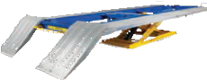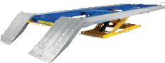

Car-O-Liner BR5500 Frame & Tilt Lift

(CARNA34640KT B83)
Car-O-Liner BR6300 Frame & Tilt Lift (CAR33907-KIT)
Additional Option: Required for Vans certification.

Straightening Bench Fixtures

Facilities are required to show proof of rented fixtures when asked by a Mercedes-Benz Auditor or staff.
Due to the quick turnaround time that our customers demand, we strongly recommend owning the necessary fixtures so that they are readily available.

Mercedes-Benz Approved Fixtures:

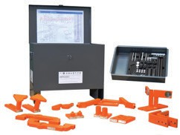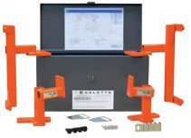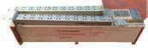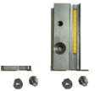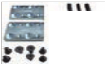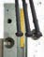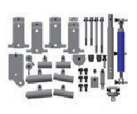

Celette System Sprinter (article number7906.300)
*Please note the Sprinter 4x4 will require a different fixture set. This can be rented.
Celette System Metris (article number 7447.5B)
Carbench System Sprinter (article number 020714)
Carbench System Metris
(article number 020519 + 020763)
Car-O-Liner

MB B766 SPRINTER 2020 - ADDITIONAL KIT TO B731 AND EVO KIT 40218

Spray Booth

Facilities are required to have a Down Draft spray booth with a minimum 12ft interior clearance to fit the “High Roof” option and 27ft interior length for our extended length option that are offered for our Vans.
These booths use the same chamber for paint and convection drying and utilize a make-up unit to supply the spray booth with filtered air.

Must be UL & CE approved in conjunction with OSHA, NFPA, EPA as well as state and local codes and regulations.
The minimum specifications are:
- Intake and Exhaust airflow rating of 14,000 CFM
- Air filters (paint arrestors) must have a 98% efficiency
- Lighting system which uses daylight lamp that will provide at least a 96 CRI
- Brightness level should be at a minimum of 100 foot-candles at the cabin floor or filter grate
- Heating unit with direct fired burners at a minimum of 1.0 MBTU
- Grade “D” quality air breathing system

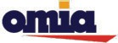
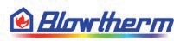

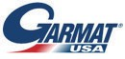


Heavy Duty Lift

Facilities are required to have a heavy duty lift that is rated for minimum 12,500lbs - 15,000lbs preferred
Lift must accommodate the vehicle and any accessories or extra weight that has been added to the vehicle by the owner.

Must be UL & CE approved in conjunction with OSHA, as well as state and local codes and regulations.
Mercedes-Benz Recommended Manufactures:
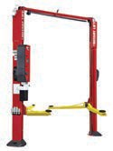
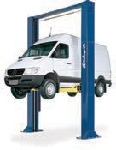
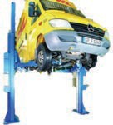
Rotary Challenger Nussbaum & Company

Mercedes-Benz
April 2026
Certified Collision Center






